# Aim: Draw the Line plot, Scatter plot, Box plot using plotly, matplotlib and seaborn libraries in python on random dataset.

**IDE:** Excel, Tableau, Spyder IDE

**Theory:**

**Line Chart**

A line graph is a visual that displays a series of data points connected by a straight line. It is commonly used to visually represent quantitative data over a certain time period. Typically, independent values such as time intervals are plotted on the horizontal x-axis while dependent values such as prices, sales and the like go to the vertical y-axis. Negative values, if any, are plotted below the x-axis. The line's falls and rises across the graph reveal trends in your dataset: an upward slope shows an increase in values and a downward slope indicates a decrease.

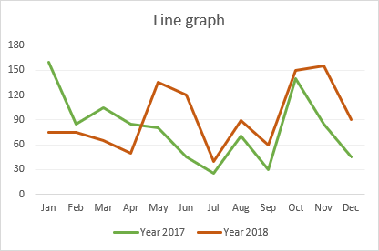

# When to use a line graph

Line charts work well in the following situations:

1. **Good visualization of trends and changes**. Of all the variety of Excel charts, a line graph is best suited for showing how different things change over time.
2. **Easy to create and read**. If you are looking for a simple and intuitively clear way to visualize large and complex data, a line graph is the right choice.
3. **Show relationships between multiple data sets**. A multiple line graph can help you reveal relationships between two or more variables.

# When not to use a line graph

There are a few cases in which a line graph is not suitable:

1. **Not suited for large data sets**. Line graphs are best to be used for small data sets under 50 values. More values would make your chart more difficult to read.
2. **Best for continuous data**. If you have discrete data in separate columns, use a [bar graph](https://www.ablebits.com/office-addins-blog/make-bar-graph-excel/)
3. **Not suited for percentages and proportions**. To display data as a percentage of the whole, you'd better use a [pie chart](https://www.ablebits.com/office-addins-blog/make-pie-chart-excel/) or a stacked column.
4. **Not recommended for schedules**. While line charts are great to show trends over a certain period, a visual view of projects scheduled over time is better done by a [Gantt chart](https://www.ablebits.com/office-addins-blog/make-gantt-chart-excel/).

# How to make a line graph in Excel

To create a line graph in Excel 2016, 2013, 2010 and earlier versions, please follow these steps:

# Set up your data

A line graph requires two axes, so your table should contain at least two columns: the time intervals in the leftmost column and the dependent values in the right column(s).

In this example, we are going to do a **single line graph**, so our sample data set has the following two columns:

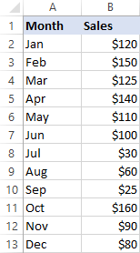

# Select the data to be included in the chart

In most situations, it is sufficient to select just one cell for Excel to pick the whole table automatically. If you'd like to plot only part of your data, select that part and be sure to include the column headers in the selection.

# Insert a line graph

With the source data selected, go to the Insert tab > Charts group, click the Insert Line or Area Chart icon and choose one of the available graph types.

As you hover the mouse pointer over a chart template, Excel will show you a description of that chart as well as its preview. To inset the chosen chart type in your worksheet, simply click its template.

In the screenshot below, we are inserting the 2-D Line graph:

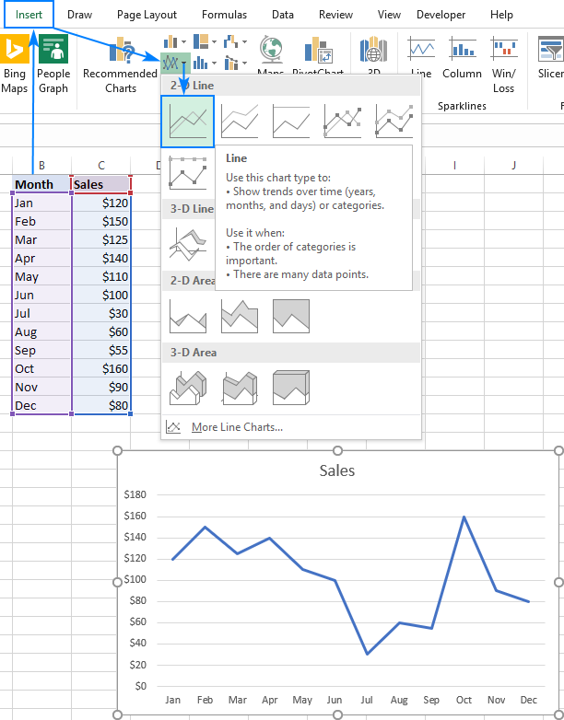

# How to graph multiple lines in Excel

To draw a multiple line graph, perform the same steps as for creating a single line graph. However, your table must contain at least 3 columns of data: time intervals in the left column and observations (numeric values) in the right columns. Each data series will be plotted individually.

With the source data highlighted, go to the Insert tab, click the Insert Line or Area Chart icon, and then click 2- D Line or another graph type of your choosing:

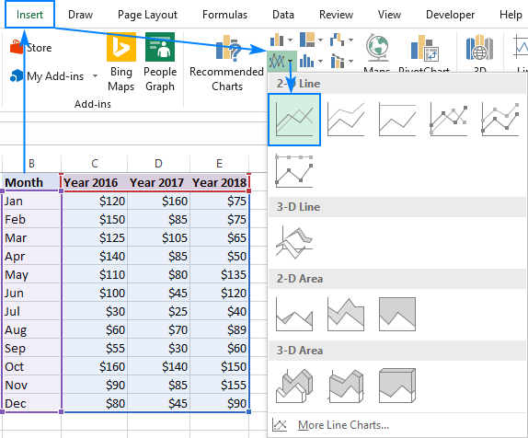

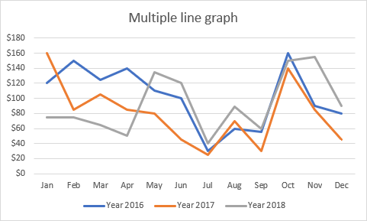A multiple line graph is immediately inserted in your worksheet, and you can now compare the sales trends for different years to one another.

When creating a multiple line chart, try to limit the number of lines to 3-4 because more lines would make your graph look cluttered and hard to read.

# Excel line chart types

In Microsoft Excel, the following types of the line graph are available:

Line. The classic 2-D line chart demonstrated above. Depending on the number of columns in your data set, Excel draws a single line chart or multiple line chart.

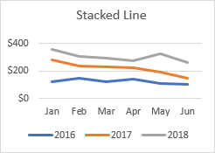Stacked Line. It is designed to show how parts of a whole change over time. The lines in this graph are cumulative, meaning that each additional data series is added to the first, so the top line is the total of all the lines below it. Therefore, the lines never cross.

100% Stacked Line. It is similar to a stacked line chart, with the difference that the y-axis shows percentages rather than absolute values. The top line always represents a total of 100% and runs straight across the top of the chart. This type is typically used to visualize a part-to-whole contribution over time.

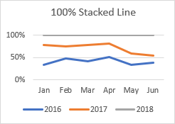

Line with Markers. The marked version of the line graph with indicators at each data point. The marked versions of Stacked Line and 100% Stacked Line graphs are also available.

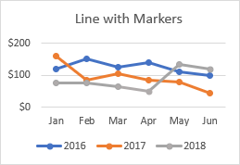

* 1. 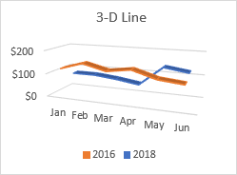Line. A three-dimensional variation of the basic line graph.

# How to customize and improve an Excel line chart

The default line chart created by Excel already looks nice, but there is always room for improvement. To give your graph a unique and professional look, it makes sense to begin with the common customizations such as:

* + - Adding, changing or formatting the [chart title](https://www.ablebits.com/office-addins-blog/excel-charts-title-axis-legend/#add-chart-title).
    - Moving or hiding the [chart legend](https://www.ablebits.com/office-addins-blog/excel-charts-title-axis-legend/#move-format-hide-chart-legend).
    - Changing the [axis scale](https://www.ablebits.com/office-addins-blog/excel-charts-title-axis-legend/#axis-scale) or choosing another number format for [axis values](https://www.ablebits.com/office-addins-blog/excel-charts-title-axis-legend/#format-numbers-axis-labels).
    - Showing or hiding the [chart gridlines](https://www.ablebits.com/office-addins-blog/excel-charts-title-axis-legend/#show-hide-gridlines).
    - Changing the chart [style](https://www.ablebits.com/office-addins-blog/excel-charts-title-axis-legend/#change-chart-type-styles) and [colors](https://www.ablebits.com/office-addins-blog/excel-charts-title-axis-legend/#change-default-chart-colors).

In general, you can adjust any element of your graph as explained in [How to customize a chart in Excel](https://www.ablebits.com/office-addins-blog/excel-charts-title-axis-legend/). Additionally, you can do a few customizations specific to a line graph as explained below.

# How to show and hide lines in the chart

While making a graph with multiple lines, you may not want to display all the lines at a time. So, you can use one of the following methods to hide or remove the irrelevant lines:

1. **Hide columns**. In your worksheet, right-click a column you don't want to plot in the graph, and click *Hide*. Once the column is hidden, the corresponding line will disappear from the graph straight away. As soon as you [unhide the column](https://www.ablebits.com/office-addins-blog/excel-unhide-columns/), the line will be right back.
2. **Hide lines in the chart**. If you don't want to mangle the source data, click the *Chart Filters* button on the right side of the graph, uncheck the data series you want to hide, and click *Apply*:

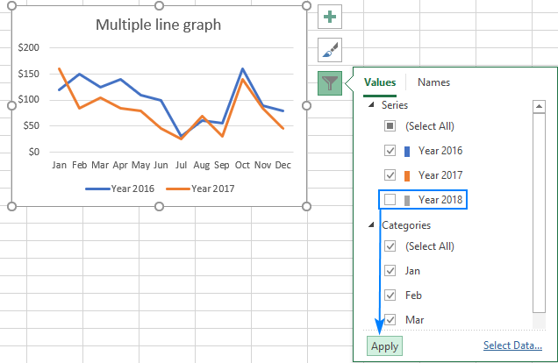

Delete a line. To permanently delete a certain line from the graph, right-click it, and select Delete from the context menu.

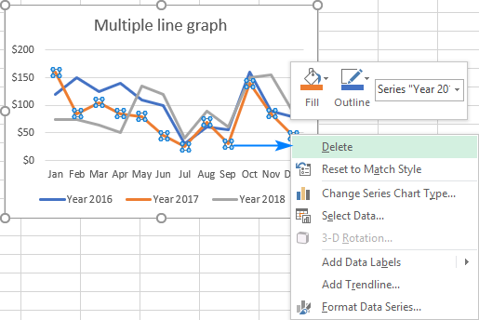

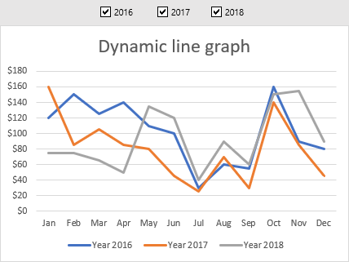Dynamic line graph with check boxes. To show and hide lines on the fly, you can insert a check box for each line, and make your graph respond to selecting and clearing the check boxes. The detailed instructions to create such a graph can be found here.

Scatter Plot

A Scatter Plot can also be known as a scatter diagram or an XY graph. A Scatter plot is a 2d graph presenting the relationship between two variables, represented by the X and Y axes. The X-axis or the horizontal axis is the side-to-side line on a graph. Meanwhile, the Y-axis or the vertical axis is a graph up and down the line. It shows how changes in one variable can affect another variable.

# Steps on How to Make a Scatter Plot in Excel.

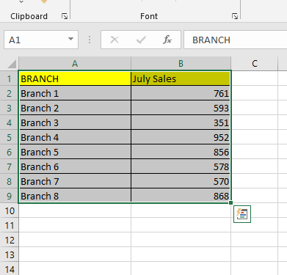Prepare and Select your data.

Go to the Insert tab and find the Insert Scatter (X, Y) or Bubble Chart option in the Charts Group.

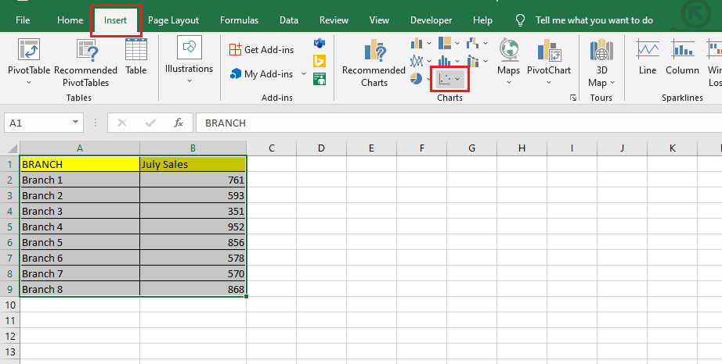

In the Insert Scatter (X, Y) or Bubble Chart option, you can choose five scatter chart types: Scatter Chart.

Scatter Chart with Smooth Lines and Markers. Scatter with Smooth Lines.

Scatter Chart with Straight Lines and Markers. Scatter Chart with Straight Lines.

Note: Scatter Charts are the best option When dealing with more than two data points.

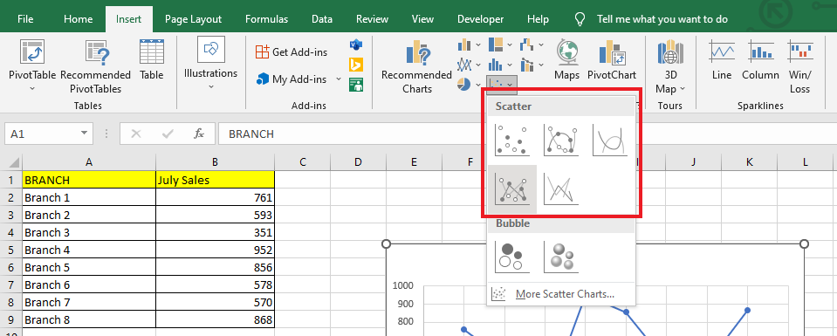

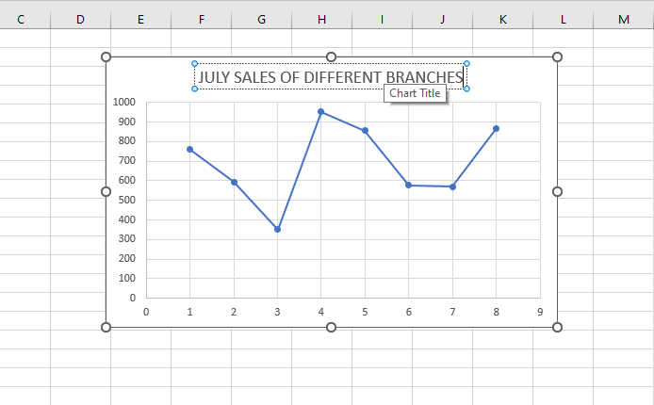After you've chosen a scatter plot chart type for your data, change the Chart Title of your scatter graph.

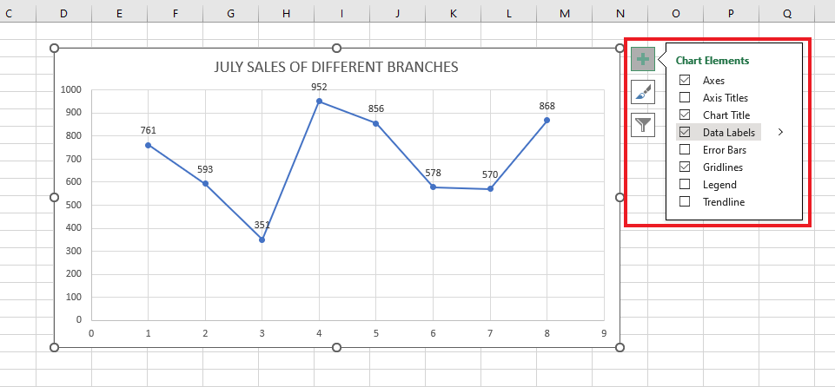To format the data labels, go to the Chart Elements option and click "Data labels." Each data point will have numeric values.

In the Chart Design Tab, choose a Chart Style to improve your data visualization.

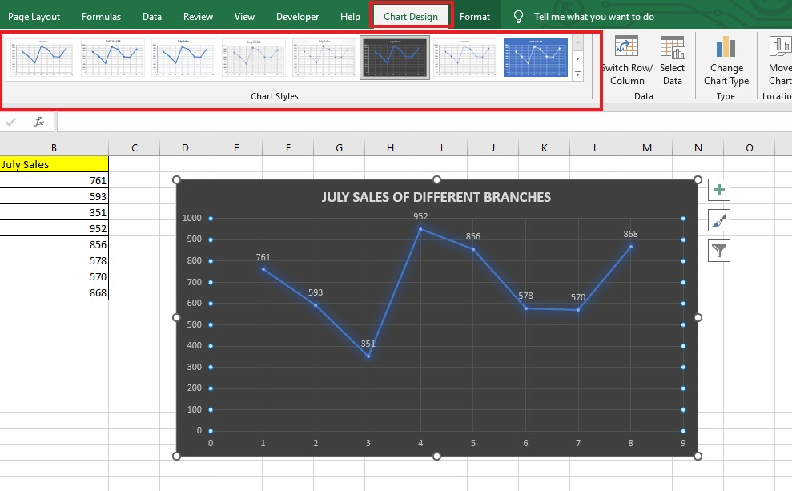

Add Axis Titles under Chart Elements.

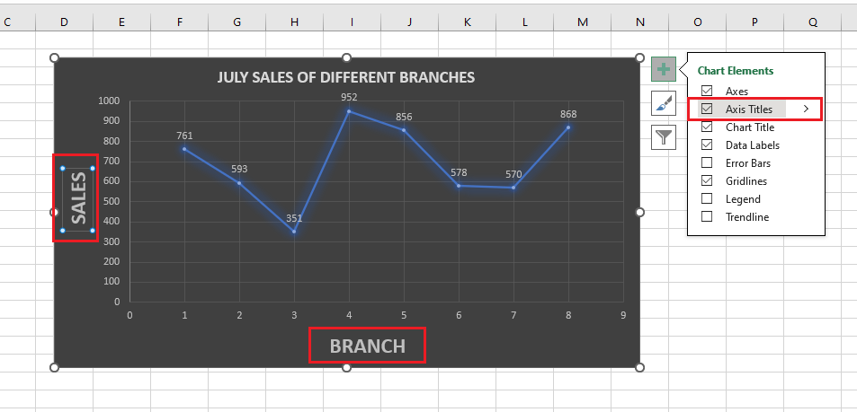

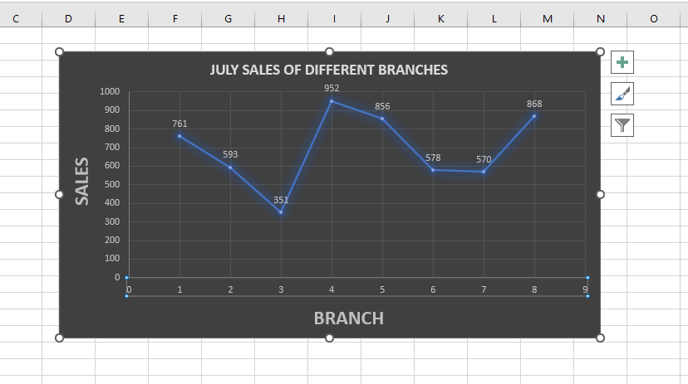Finished Scatter Chart.

Box Plot

A box and whisker chart shows distribution of data into quartiles, highlighting the mean and outliers. The boxes may have lines extending vertically called “whiskers”. These lines indicate variability outside the upper and lower quartiles, and any point outside those lines or whiskers is considered an outlier.

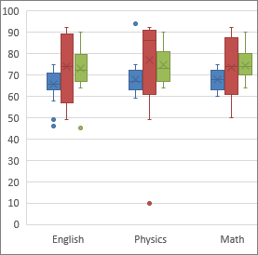Box and whisker charts are most commonly used in statistical analysis. For example, you could use a box and whisker chart to compare medical trial results or teachers' test scores.

# Create a box and whisker chart

Select your data—either a single data series, or multiple data series.

(The data shown in the following illustration is a portion of the data used to create the sample chart shown above.)

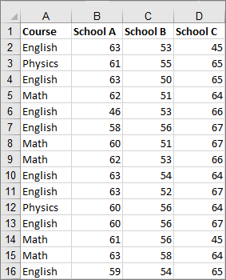

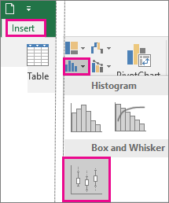In Excel, click Insert > Insert Statistic Chart >Box and Whisker as shown in the following illustration.

Change box and whisker chart options

1. Right-click one of the boxes on the chart to select that box and then, on the shortcut menu, click Format Data Series.
2. In the Format Data Series pane, with Series Options selected, make the changes that you want. (The information in the chart following the illustration can help you make your choices.)

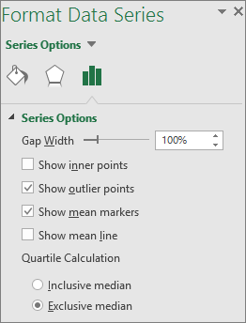

|  |  |
| --- | --- |
| **Series option** | **Description** |
| **Gap width** | Controls the gap between the categories. |
| **Show inner points** | Displays the data points that lie between the lower whisker line and the upper whisker line. |
| **Show outlier points** | Displays the outlier points that lie either below the lower whisker line or above the upper whisker line. |
| **Show mean markers** | Displays the mean marker of the selected series. |
| **Show mean line** | Displays the line connecting the means of the boxes in the selected series. |
| **Quartile Calculation** | Choose a method for median calculation:   * **Inclusive median** The median is included in the calculation if **N** (the number of values in the data) is odd. * **Exclusive median** The median is excluded from the calculation if **N** (the number of values in the data) is odd. |

**Pre Lab Exercise:**

* 1. What is line plot used for in Excel?
  2. What is scatter plot in Excel?
  3. Compare Scatter chart and Box plot

**Pre Lab Tasks:**

Perform the following tasks:

Task 1: Draw line plot using superstore data (state vs. Quantity & state vs. profit)

**Results:**-

x

**Results:**-

Task 2: Draw scatter plot using superstore data (Sales vs. Quantity)

**Results:**-

Task 3: Draw box plot using superstore data

**Results:**-

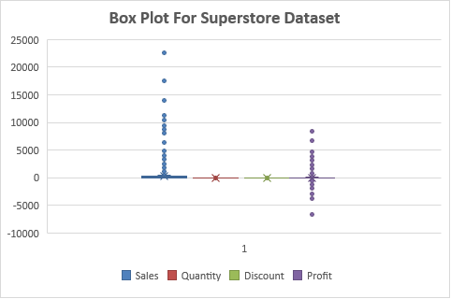

**In Lab Tasks:**

Perform the following tasks:

Task 1: Draw line plot using superstore data (state vs. Quantity & state vs. profit)

**Results:**-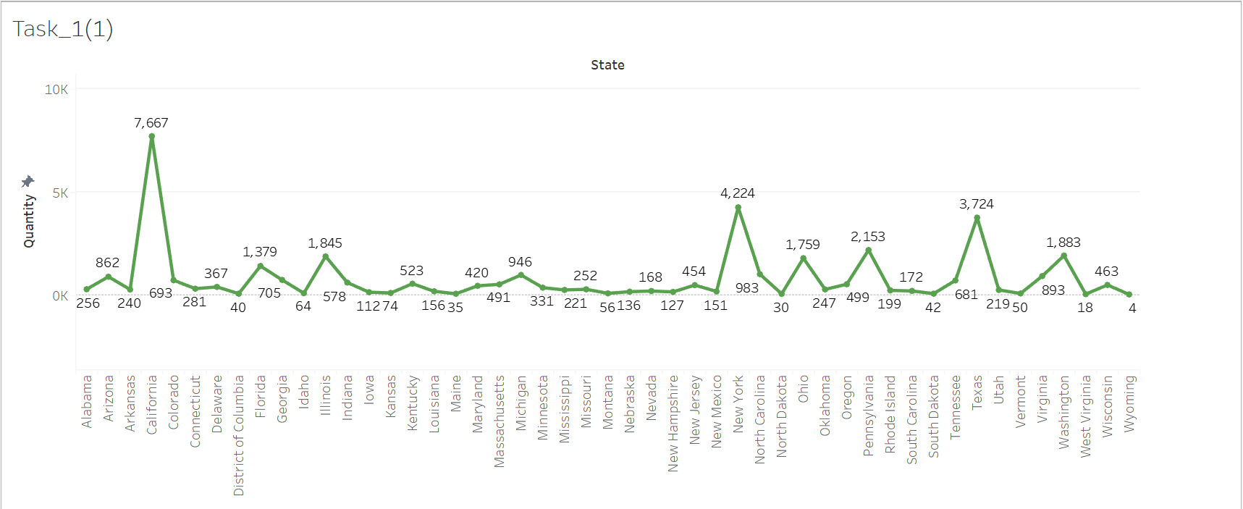

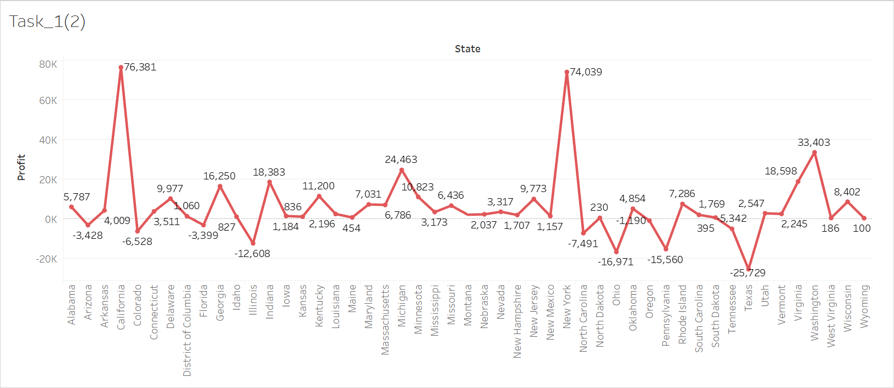

Task 2: Draw scatter plot using superstore data (Sales vs. Quantity)

**Results:**-

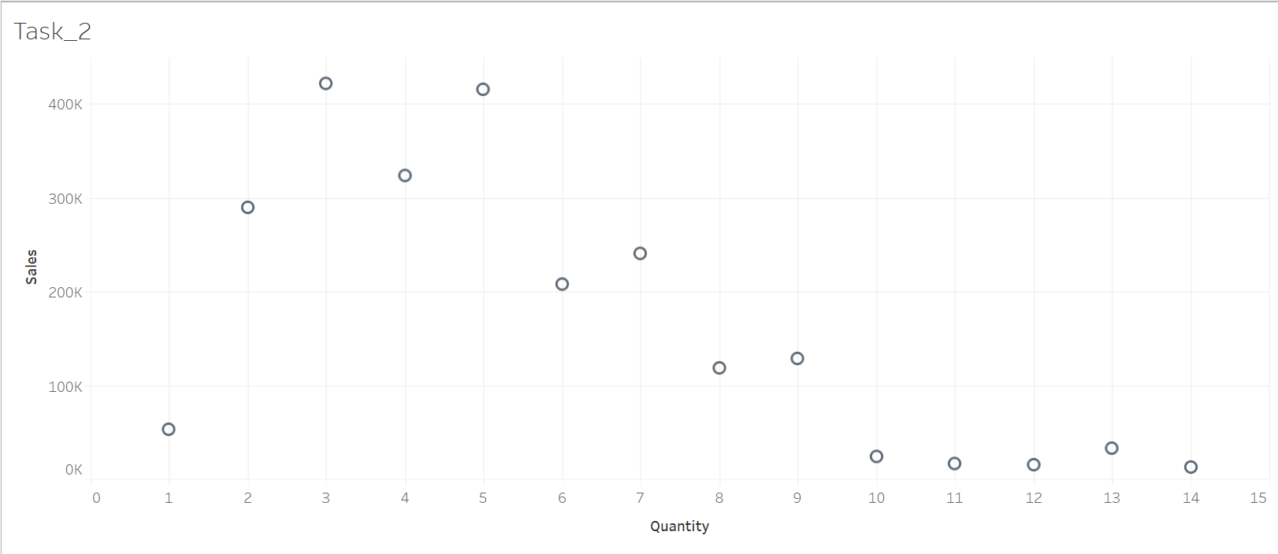

Task 3: Draw box plot using superstore data

**Results:**-

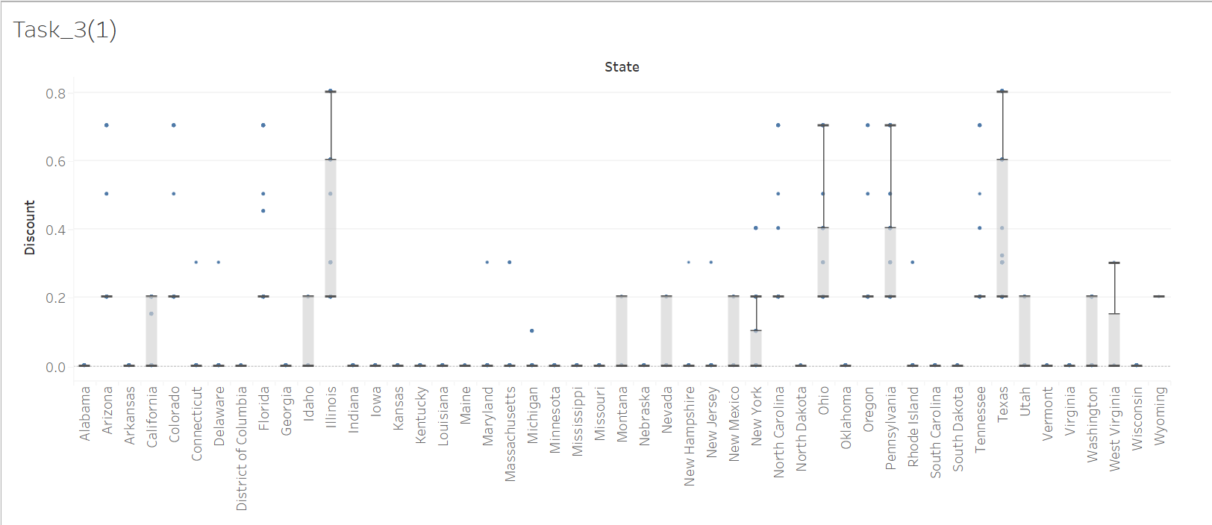

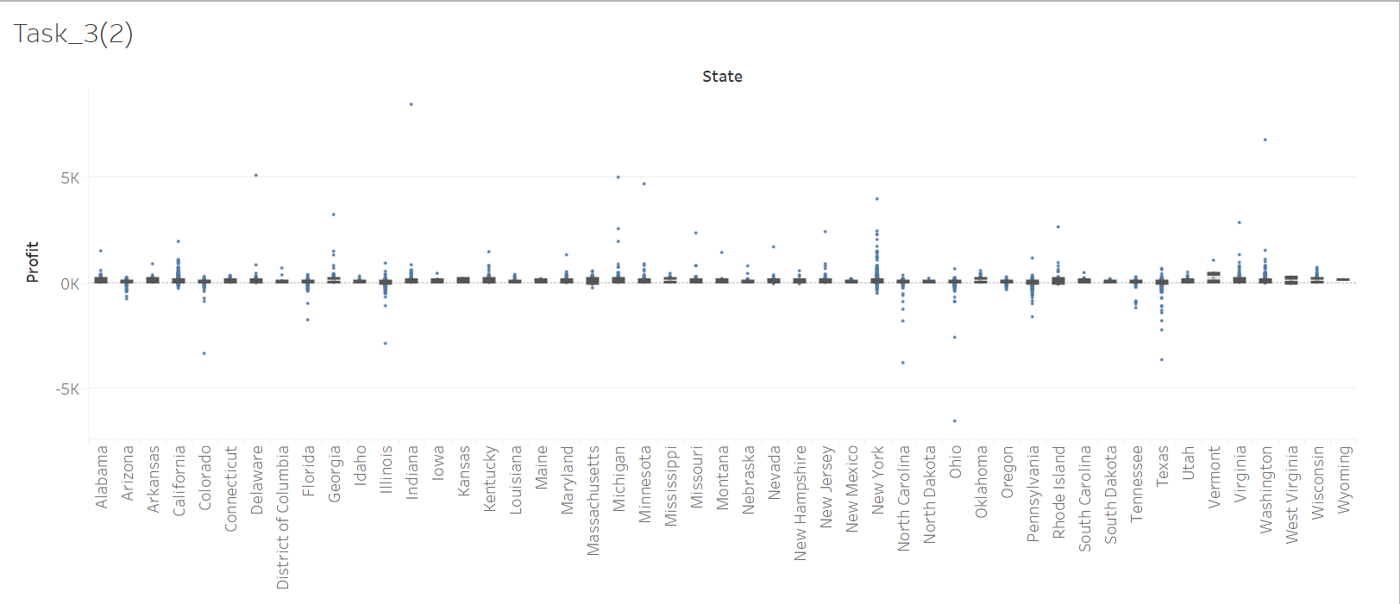

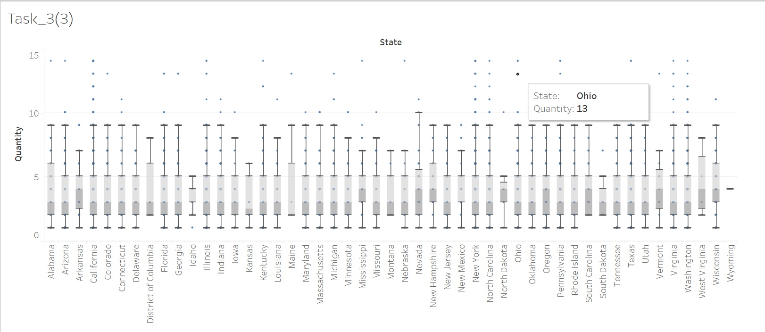

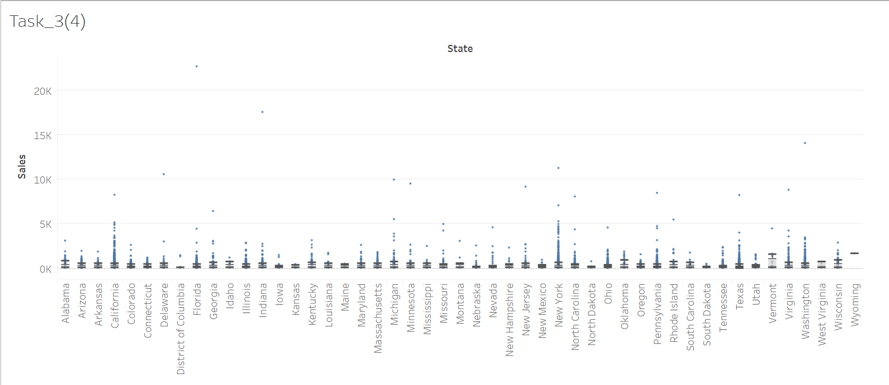

**Observation and Result Analysis:**

Write the final observation and process corresponding to each task

**1. _ _**

**_ _**

**_ _**

**2. _ _**

**_ _**

**_ _**

**3. _ _**

**_ _**

# Post Lab Exercise:

**Python Implementation**

# Reference Link: https://[www.kaggle.com/code/alaasedeeq/superstore-data-analysis-with-plotly](http://www.kaggle.com/code/alaasedeeq/superstore-data-analysis-with-plotly)

**Perform the following tasks:**

**Pre-Requisites :-**

# Importing necessary libraries

import matplotlib.pyplot as plt

import numpy as np

import pandas as pd

import seaborn as sns

# Reading the dataset from an Excel file

Dataset = pd.read_excel("D:/Aryan Data/Usefull Data/Semester - 4/Data Visulization and Dashboards/Lab Manual/Exp-4 Creating line plot scatter plot and box plot-1/Sample - Superstore.xlsx", "Orders")

Task 1: Draw line plot using superstore data (state vs. Quantity & state vs. profit)

**Code :-**

# Line Chart for State vs Quantity

Quantity_State_Grouped_Dataset = Dataset.groupby(by="State")["Quantity"].sum()

# Plotting the line chart

Quantity_State_Grouped_Dataset.plot(kind="line", color="b")

plt.title("Line Chart of State Vs Quantity")

plt.xlabel("State")

plt.ylabel("Quantity")

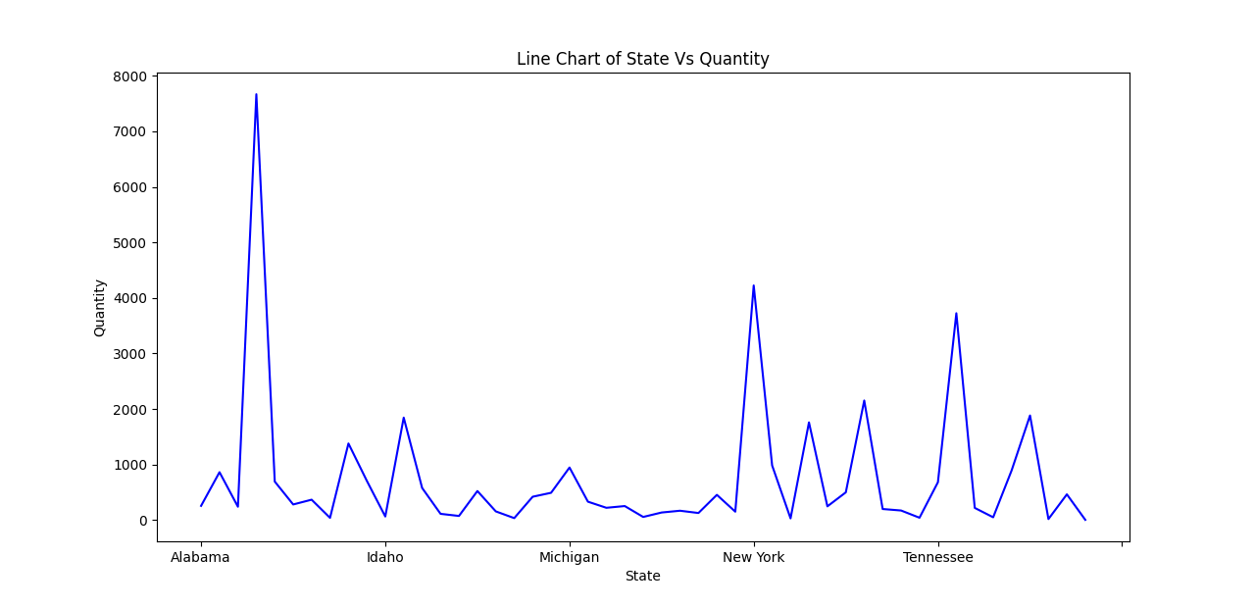plt.show()

**Results:**-

# Line Chart for State vs Profit

Profit_State_Grouped_Dataset = Dataset.groupby(by="State")["Profit"].sum()

# Plotting the line chart

Profit_State_Grouped_Dataset.plot(kind="line", color="b")

plt.title("Line Chart of State Vs Profit") # Fix the title to represent Profit

plt.xlabel("State")

plt.ylabel("Total Profit")

plt.show()

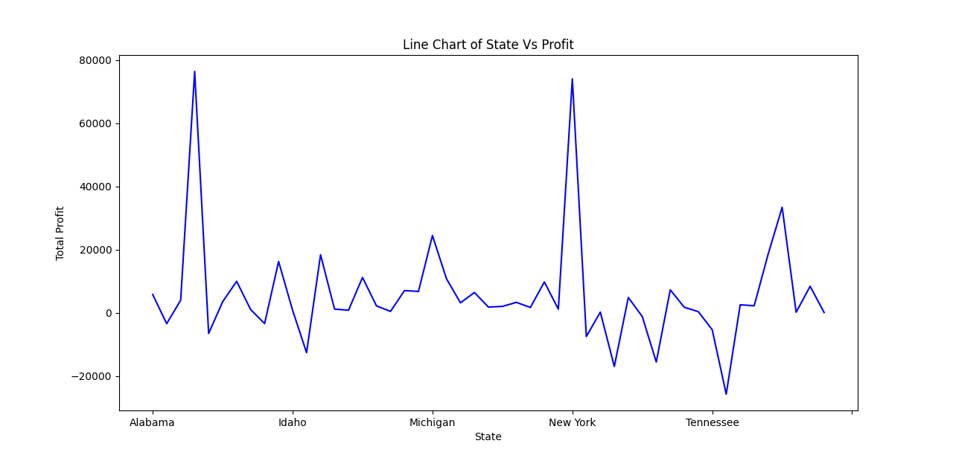

Task 2: Draw scatter plot using superstore data (Sales vs. Quantity)

**Code :-**

# Scatter Plot for Quantity vs Total Profit

Total_Sale_Grouped_Total_Sale = Dataset.groupby(by="Quantity")["Profit"].sum()

Total_Sale_Grouped_Total_Sale = Total_Sale_Grouped_Total_Sale.reset_index()

# Plotting the scatter plot

plt.scatter(

Total_Sale_Grouped_Total_Sale["Quantity"],

Total_Sale_Grouped_Total_Sale["Profit"],

c="g",

marker="o",

)

plt.title("Scatter Plot for Total Profit Vs Quantity")

plt.xlabel("Quantity")

plt.ylabel("Total Profit")

plt.show()

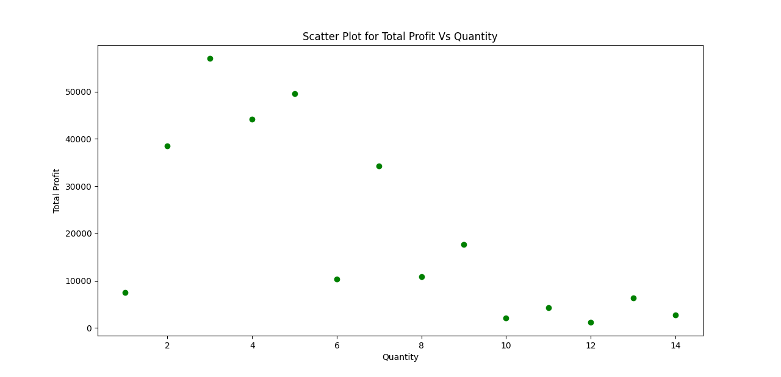**Results:**-

Task 3: Draw box plot using superstore data

**Code :-**

# Box Plot using Matplotlib

Parameters_of_Box_Plots = ["Sales", "Quantity", "Discount", "Profit"]

# Creating a box plot for selected parameters

plt.figure(figsize=(12, 8))

plt.boxplot([Dataset[column] for column in Parameters_of_Box_Plots], labels=Parameters_of_Box_Plots,)

plt.title("Box Plot for Sales, Quantity, Discount, and Profit")

plt.xlabel("Columns")

plt.ylabel("Values")

plt.show()

# Result :-

# 